***Setting up of maven inside eclipse 🡪***

1. Go to Eclipse Marketplace ( Help -> Eclipse Marketplace )
2. Install m2e plugin for eclipse 🡪

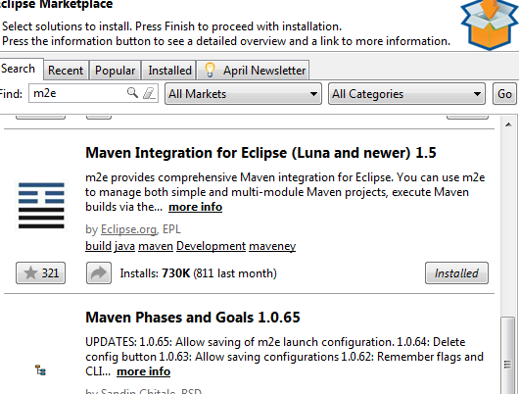

1. Go to Window 🡪 Preferences 🡪 Maven 🡪 User Settings

Make sure the value of settings.xml is of the below format ( replace my soeid with yours in the below path ).

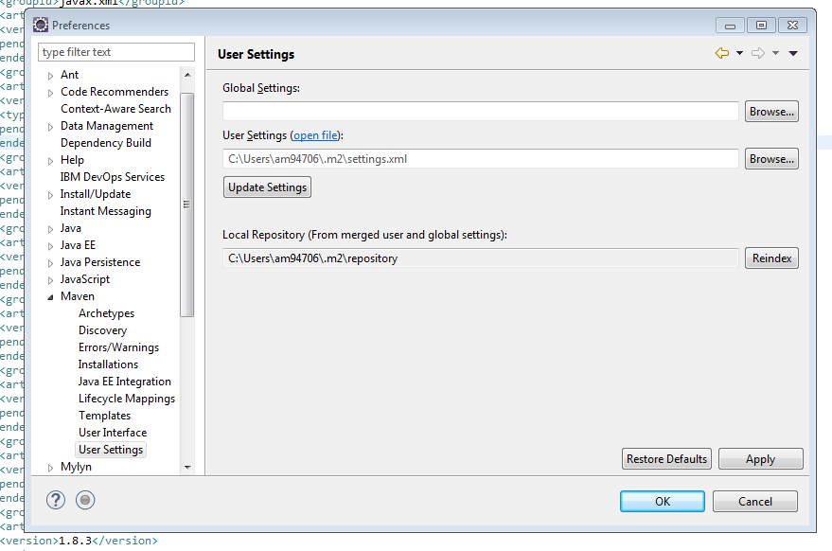

1. Make that directory structure.

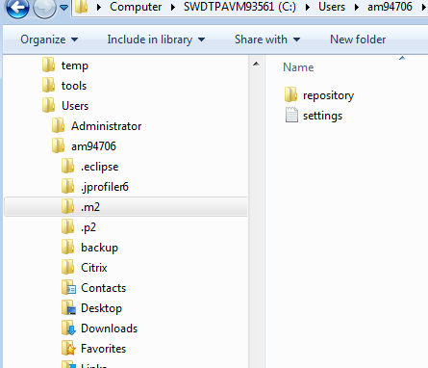

1. Inside .m2 folder copy the attached settings.xml

–

1. Import the project into your workspace. The project will have a maven property associated with it 🡪

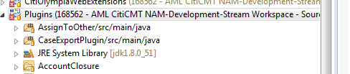

1. Now right click on the pom.xml that is directly below the project and do a clean build of mvn

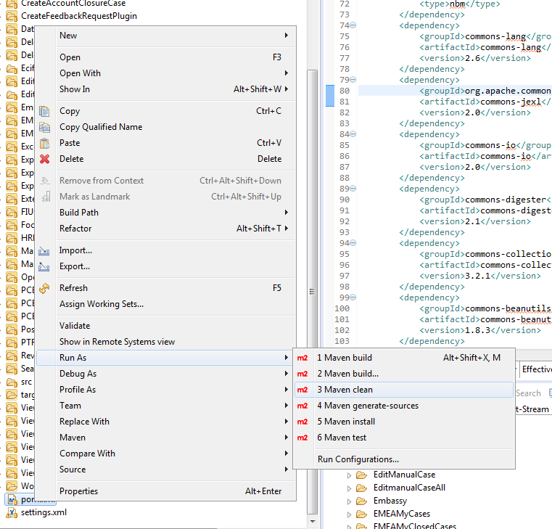

1. Next do a install. The first time you do this it will take long time , since it takes all the libraries from mvn repo and copies it to your local.

***Setting up of maven outside eclipse :***

This is optional, however it does helps if you have maven setup in your local workstation also (outside eclipse).

The maven zip is available at 🡪 H:\CBS_users\Anindya\RTC\tools

Unzip it in your local hard drive. I have unzipped it in the following location 🡪

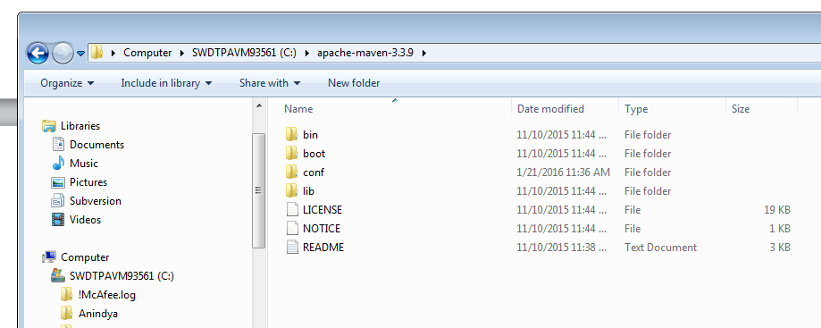

Now we have to add it to the user PATH variable so that it can be accessed from anywhere.

Click on the start menu and type user accounts as below 🡪

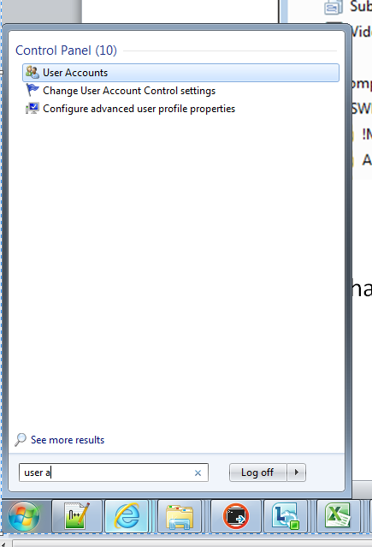

Once opened click on “Change my environment variables” as below 🡪

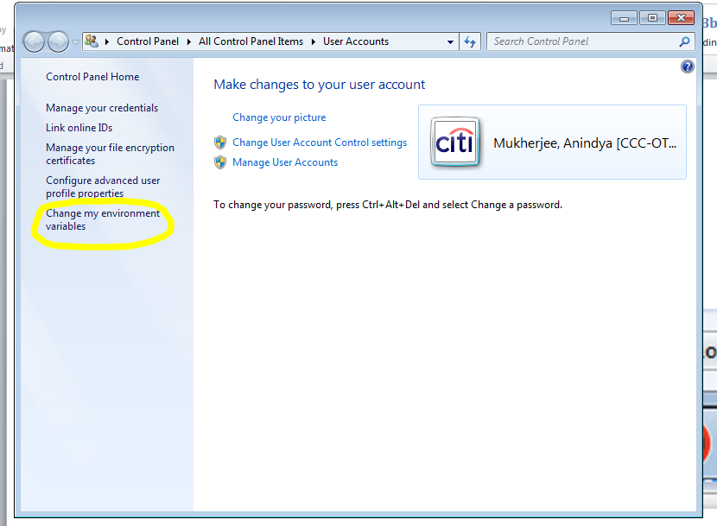

The following pop up will come 🡪

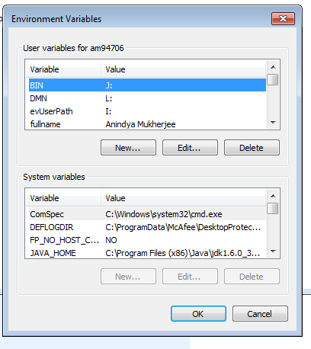

Edit the PATH variable ( for the User ) and enter the following 🡪 %PATH%;C:\apache-maven-3.3.9\bin

Save the variable ( as below ) 🡪

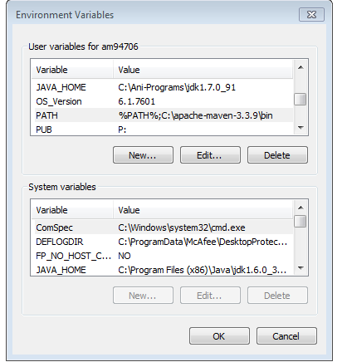

Mvn has been setup now. Open a new console an type 🡪 mvn –version

It should give you the version of mvn used :